**CEW LAB1**

**Answer#1**

#include <stdio.h>

int main()

{

int emp_id,salary_per_hour=999;

float hours_worked;

printf("Enter Employee ID:\t");

scanf("%d",&emp_id);

printf("\nEnter total hours worked in this month:\t");

scanf("%f",&hours_worked);

printf("The total salary of the Employee(ID = %d): Rs.%.2f/= ", emp_id, salary_per_hour * hours_worked);

return 0;

}

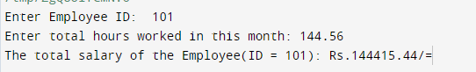

**Answer#2**

#include <stdio.h>

int main() {

float height, width;

printf("Enter Height of the Rectangle:\t");

scanf("%f",&height);

printf("\nEnter Width of the Rectangle:\t");

scanf("%f",&width);

printf("The Perimeter of the Rectangle: %.2f units",height*2+width*2);

return 0;

}



**Answer#3**

#include <stdio.h>

int main() {

float height;

printf("Enter Height of the Person in centimeters:\t");

scanf("%f",&height);

if(height<150)

printf("The Person is DWARF");

else if(height==150)

printf("The Person is AVERAGE");

else if(height>=165)

printf("The Person is TALL");

else

printf("The Person is between DWARF and TALL but not AVERAGE");

return 0;

}



**Answer#4**

#include<stdio.h>

int decimal_to_binary(num)

{

int dec = num,bin=0,rem=0,place=1;

while(dec)

{

rem=dec%2;

dec=dec/2;

bin=bin + (rem*place);

place=place*10;

}

return bin;

}

int main()

{

printf("DECIMAL TO BINARY CONVERTER\n\n");

int num;

printf("ENTER A DECIMAL NUMBER: ");

scanf("%d",&num);

printf("BINARY EQUIVALENT: %d",decimal_to_binary(num));

return 0;

}

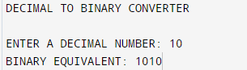

**Answer#4**

#include<stdio.h>

int fab(a,b,num)

{

int x=a,y=b,z,n=num;

if (n==0)

return 0;

else

{

z=x+y;

printf("%d ",z);

return fab(y,z,n-1);

}

}

int main()

{

int a=0,b=1,num;

printf("FIBONACCI SERIES PRINTER\nEnter nth term of fibonacci series:\t ");

scanf("%d",&num);

printf("1 ");

fab(a,b,num);

}

